Title (Times New Roman, 16 font, bold)

doi: Please leave this as blank
Published online: Please leave this as blank

Running title: Times New Roman, font 12 (50 characters including space max)

John Doe MD^{1,2}, Mary Jane MSc¹ (Times New Roman, font 10.5)

¹ Affiliation (Department, Institution, City, Country)
² Affiliation (Department, Institution, City, Country)

Authors’ email addresses and contributions:
JD: john.doe@email.com
Contribution: conceived the study question, and contributed to the study design, supervision of data collection, data analysis and interpretation, and writing the manuscript.

MJ: maryjane@hotmail.com
Contribution: undertook data collection and data analysis, and contributed to data interpretation, and writing the manuscript.

Corresponding Author: Dr John Doe, Affiliation (Department, Institution, City, Country PO box). Tel: +1234567. Fax: +1234567. Email: john.doe@email.com
ABSTRACT
Background and Objectives: xxxxxxxxxxxxxxxx xxxxxxxxxxxxxx xxxxxxxxxxxxxxxxxxxxxxxxxxxx xxxxxxxxxxx. Methods and Study Design: xxxxxxxxxxxxxxxxxxxxxxxxxxxx xxxxxxxxxxxxxxxxxxxxxxxxxxxxxxxxxxxx xxxxxxxxxxxxxxxxxxxxxxxxxxxxxxxxxx xxxxxxxxxxxxxxxx xxxxxxxxxxxx xxxxxxxxxxxxxxxxxxxxxxxxxxxxxxxxxxxxxxxxxxxxxxxxxxxxxxxxxxxxx. Results: xxxxxxxxxxxxxxxxxxxxxxxxxxx xxxxxxxxxxxx xxxxxxxxxxx. Xxxxxxxxxxxxxxxx xxxxxxxxx xxxxxxxxx Conclusions: xxxxxxxxxxxxxxxxxxxxxxxxxx. Xxxxxxxxxxxxxxxx xxxxxxxxxxxxxxxx (Times New Roman, font 12)

Key Words: 5 keywords (Times New Roman, font 12 bold)

INTRODUCTION
Xxxxxxxxxxxxxxxxxxxx xxxxxxxxxxxxxxxxxx xxxxxxxxxxxxxxxxxx.¹ xxxxxxxxxxxxxxxx, xxxxxxxxxxx, xxxxxxxxxxx,² xxxxxxxxxxxxxxxx xxxxxxx xxxxxxxxxxx xxxxxxxxxx, xxxxxxxxxxxxxxxxxxxxxx.^{3,4}
Xxxxxxxxxxx xxxxxxxxxxxxxxxxxxxx xxxxxxxxxxxx xxxxxxxxxx.¹ xxxxxxxxxxxxx xxxxxxxxxxxxx xxxxxxxxxxxxxxxx xxxxxxxxxxxxxxxxx xxxxxxxxxxxxxx xxxxxxxxx.⁵ xxxxxxxxxxxxxxxxxxx xxxxxxxxxxxxxxxxxxx xxxxxxxxxxxxxx.⁶
1. Times New Roman, font 12
2. Note references are AFTER comma or fullstop

MATERIALS AND METHODS
Xxxxxxxxxxxx xxxxxxxxxxx xxxxxxxxxxxx.¹³ xxxxxxxxxxx xxxxxxxxxxx xxxxxxxxxx xxxxxxxxxxxxx. Xxxxxxxxxxx xxxxxxxxxxxxxx xxxxxxxxxx.
1. Times New Roman, font 12
2. Please state ethical approval and clinical registration number

Sub heading (Times New Roman, font 12, Italics + Bold)
Sub sub heading (Times New Roman, font 12, bold)
Xxxxxxxxxxxxxxx xxxxxxxxxxxxxxx xxxxxxxxxxx xxxxxxxxxxx. Xxxxxxxxxxx xxxxxxxxxxxxxxxxx xxxxxxxxxxxxx xxxxxxxxxxxxxxx. xxxxxxxxxxxxxxx.
Xxxxxxxxxxxxxxx xxxxxxxxxxxxxx xxxxxxxxxxxxxxx xxxxxxxxxxxxxxxxx xxxxxxxxxxxxxxxxxxxxxxxxxxx xxxxxxxxxxxxxxxxxxxxx xxxxxxxxxxxxxxxxxxxx xxxxxxxxxxxxxxx.
Xxxxxxxxxxxxxxxxxxxxxxxxx xxxxxxxxxxxxxxxxx xxxxxxxxx xxxxxxxx xxxxxxxxxxxxxxxxxxxxxxxxxxxxxxxxxxxx.
1. Times New Roman, font 12

Sub sub heading
Xxxxxxxxxxxxxxxxxxxx xxxxxxxxxxxxxxx xxxxxxxxxxxxxxxxxxxxxx.
1. Times New Roman, font 12

Sub heading
Xxxxxxxxxxxx xxxxxxxxxxxxxxx xxxxxxxxxxxxxxx xxxxxxxxxxxxx xxxxxxxxxxxxx xxxxxxxxxxxxxxx xxxxxxxxxxxxxx xxxxxxxxxxxxxx xxxxxxxxxxxxx. Xxxxxxxxxxxxxxxx xxxxxxxxxxxxxxxxx xxxxxxxxxxxxxxxxxxxxxxxxxxxxxxxxxxxxxxxxxxx xxxx xxxxxxxxxxxxxxxxxxxxxxx xxxxxxxxxxxxxxxxx.
1. Times New Roman, font 12

RESULTS
Xxxxxxxxxxxxxxx xxxxxxxxxxxxxxxxxxxxxxxxxxxx xxxxxxxxxxxx xxxxxxxxx xxxxxxxxxxxxxxxxxxxxxxxxxxxxxxxxx xxxxxxxxxxxxxxxxxxxxxxxxxxx xxxxxxxxxxxxxxxxxxxxxxxx xxxxxxxxxxxxxxxxxx xxxxxxxxxxxxxxxxxx. xxxxxxxxxxxxxxxxxxxxxxxxxxxxxxxxxxxxxxxxxxxxxxxxxxxxxxx. xxxxxxxxxxxxxxxxx, xxxxxxxxxxxxx, xxxxxxxxxxxxxxxxx, xxxxxxxxxxxxx.
1. Times New Roman, font 12

DISCUSSION
Xxxxxxxxxxxxxxxxxxx xxxxxxxxxxxxxxxxxxxxx xxxxxxxxxxxxxxxxxxxxxxx xxxxxxxxxxxxxxxxxxxxx xxxxxxxxxxxx. xxxxxxxxxxxxxxxx xxxxxxxxxxxxx.¹⁴ xxxxxxxxxxx xxxxxxxxxxxxx xxxxxxxxxxxxxx xxxxxxxxxxxxxx.^{8,9}
Xxxxxxxxxxxxxxxxx xxxxxxxxxxxxxxxx xxxxxxxxxxxxxxxxxxxx xxxxxxxxxxx, xxxxxxxxxxxxxxxx xxxxxxxxxxxxxxxxx xxxxxxxxxxxx xxxxxxxxx. Xxxxxxxxxxxxxx xxxxxxxxxxxxxxxxx xxxxxxxxxxxx xxxxxxxxxxxx xxxxxxxxxxxxxxxx, xxxxxxxxxxxxx xxxxxxxxxxxx xxxxxxxxxxxxxxxxxx.²
Xxxxxxxxxxxxxxxxxxxx xxxxxxxxxxxxxxxxx xxxxxxxxxxxxxxxx.¹² xxxxxxxxxxxxxx xxxxxxxxxxxxxxxxxx xxxxxxxxxxxxxxxxxx xxxxxxxxxxxxxxxxx xxxxxxxxxxxxx xxxxxxxxxxxxxxxxxxx xxxxxxxxxxx.¹¹
1. Times New Roman, font 12

Conclusion (Times New Roman, font 12, Italics + Bold)
xxxxxxxxxxxxxx, xxxxxxxxxxxxxxx xxxxxxxxxxxx xxxxxxxxxxxxxx xxxxx, xxxxxxxxxxxxxxxxxx xxxxxxxxxxxxxxxxxxxxxxxx xxxxxxxxxxxxxxxxxxxx xxxxxxxxxxxxxxxxxxxxxxxx xxxxxxxxxxxxxxxxxxxx.
1. Times New Roman, font 12

ACKNOWLEDGEMENTS (optional)
xxxxxxxxxxxxxxxxxxxxxxxxxxxxxxxxxxx.
1. Times New Roman, font 12

AUTHOR DISCLOSURE
1. Times New Roman, font 12
2. Declare whether there’s conflict of interest
3. Declare any financial support for study

REFERENCES
1 Times New Roman, font 10.5
2 APJCN uses the Vancouver system for referencing
3 Cite names of all authors. When an article has more than ten authors, only the names of the first six authors should be given followed by ‘et al’.
Examples:
1. Green PH, Cellier C. Celiac Disease. N Engl J Med. 2007; 357:1731-43. doi: 10.1056/NEJMra071600
2. Statistics New Zealand (2013) Census QuickStats about a place: Dunedin City. http://www.stats.govt.nz/Census/2013-census/profile-and-summary-reports/quickstats-about-a-place.aspx?request_value=15022&tabname=Culturaldiversity [Accessed 2016/01/26]
3. McIntosh J, Flanagan A, Madden N, Mulcahy M, Dargan L, Walker M, Burns DT. Awareness of coeliac disease and the gluten status of ‘gluten-free’ food obtained on request in catering outlets in Ireland. Int J Food Sci Tech. 2011;46:1569-74. doi: 10.1111/j.1365-2621.2011.02656.x.

Table 1. The characteristics of participating restaurants (Times New Roman, font 10)

 |  | Number | %
Type
 | Café | 18 | 20.0
 | Family/fine dining | 20 | 22.2
 | Pub/bar | 18 | 20.0
 | Ethnic† | 18 | 20.0
 | Fast-food franchise | 16 | 17.8
Hours open per week
 | <51 | 39 | 43.3
 | 51-60 | 11 | 12.2
 | 61-70 | 18 | 20.0
 | >70 | 22 | 24.4
Average price per meal ($NZ)
 | <11 | 18 | 20.0
 | 11-20 | 38 | 42.2
 | 21-25 | 15 | 16.7
 | >25 | 19 | 21.1
Number of staff
 | <3 | 18 | 20.0
 | 3-4 | 42 | 46.7
 | >4 | 30 | 33.3
Estimated number of meals served per week
 | <201 | 30 | 33.3
 | 201-499 | 17 | 18.9
 | ≥500 | 43 | 47.8
Dunedin City Council food premises grade
 | A | 66 | 73.3
 | B | 24 | 26.7
 | C | 0 | 0
 | D | 0 | 0

†Japanese, Thai, Korean, Philippine
Footnote symbols: †, ‡, §, ¶, ††, should be used (in that order) and *, **, *** should be reserved for p values

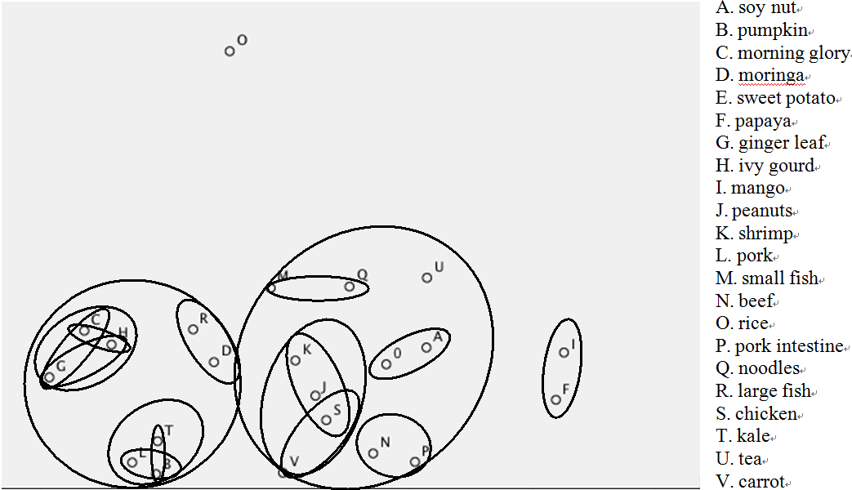

Figure 1. Aggregated multidimensional scale diagram of a pile sort activity completed by 30 Cambodian women, including 22 key iron-rich, vitamin A-rich and staple foods (Times New Roman, font 8.5; figures should be high resolution at 300dpi)

